Technology Stack [Architecture & Stack]

Date | 03 February 2026
Team ID | LTVIP2026TMIDS74755
Project Name | Rising Waters: A Machine Learning Approach To Flood Prediction
Maximum Marks | 4 Marks

Technical Architecture:
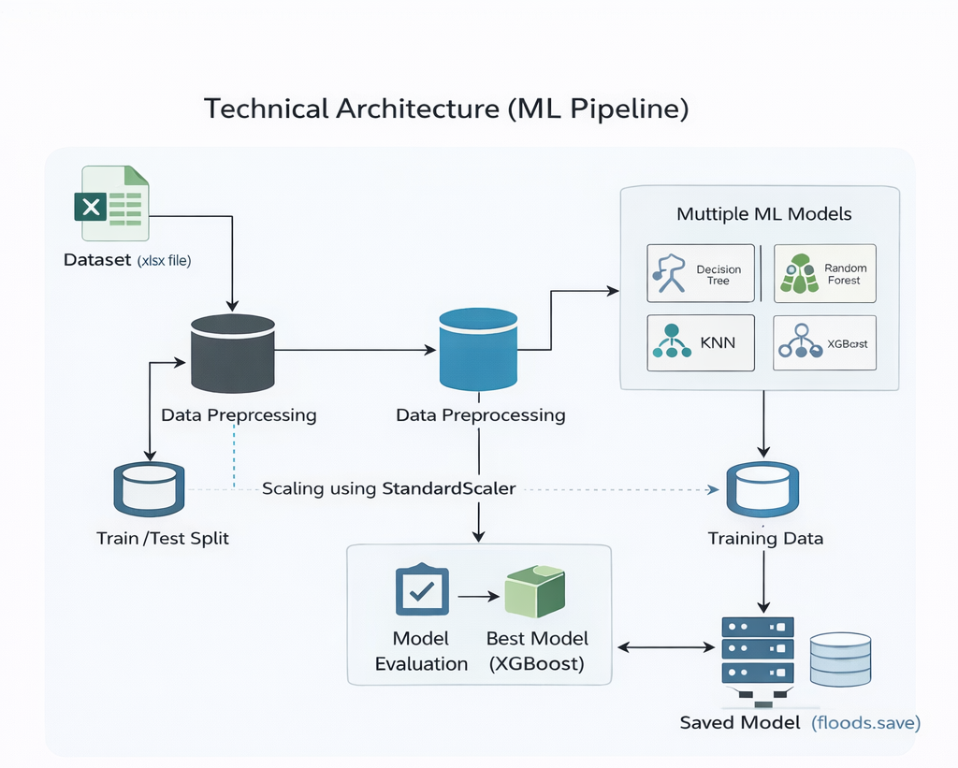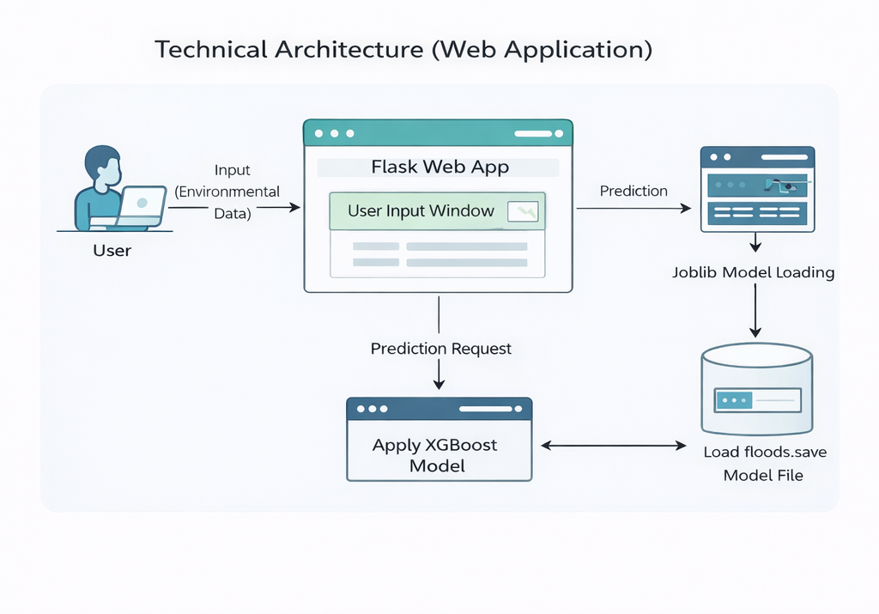

Table-1: Components & Technologies

S.No | Component | Description | Technology
1. | User Interface | Web interface through which users enter environmental parameters and view prediction results | HTML, CSS
2. | Dataset | Historical environmental data used for training and testing the model | Excel (.xlsx file)
3. | Backend Framework | Handles user requests and connects UI with ML model | Python Flask
4. | API | Used to process the input data and return prediction results | Flask Routing
5. | Application Logics | Implements preprocessing, model loading, and prediction logic | Python
6. | Machine Learning Model | Classification model developed to predict flood occurrence | Scikit-learn, XGBoost
7. | Data Pre-processing and Analysis | Data cleaning, scaling, visualization, and feature selection | NumPy, Pandas, Matplotlib, Seaborn, StandardScaler

Table-2: Application Characteristics

S.No | Characteristics | Description | Technology
1. | Open-Source Frameworks | Backend framework and ML libraries used in development | Python Flask / NodeJS, MongoDB, IBM DB2, CSS-3
2. | Security Implementations | Input validation and controlled access to prediction functionality | SSL Certs, Direct verification using Backend Framework
3. | Scalable Architecture | Additional features or larger datasets can be integrated easily. | IBM Cloud Kubernetes Service
4. | Availability | Web application can be deployed and accessed through hosting platforms | Heroku cloud hosting (for testing) , IBM cloud hosting
5. | Performance | The system generates predictions quickly with trained and saved model | Load Balancers and Distributed servers

